OPERATING & SAFETY MANUAL
DUAL CLUTCH TILTING MACHINE
Clutch Plate Positioning & Tilting Station
Manufactured by:
Karthick Engineering & Maintenance Consultants (KEMC)
No 22/50, Manickavasagam Street, Kumaran Nagar, Padi, Chennai – 600050
End User: Valeo India Pvt. Ltd.
Machine Safety Assessment: Independent Safety Consultant
Document Version: 1.0 | Date: February 2026
Safety Assessment Report Date: 16 February 2026

READ THIS MANUAL BEFORE OPERATING THIS MACHINE
Failure to follow safety instructions may result in serious injury or death.
Document Control
Document Title | Operating & Safety Manual – Dual clutch tilting machine
Document Number | KEMC-TM-OSM-001
Version | 1.0
Date of Issue | February 2026
Prepared by | Technical Documentation Team
Reviewed by | KEMC Engineering
Approved by | KEMC Management / Valeo Safety Officer
Safety Assessment Reference | Machine Safeguarding Evaluation ADVANCED – 16/02/2026
Next Review Date | February 2027 (or after any machine modification)

Version History
Version | Date | Author | Changes
1.0 | February 2026 | KEMC / Documentation Team | Initial release

ℹ NOTE: This document is to be kept readily available at the machine workstation at all times. Copies must be provided to all personnel operating, maintaining, or supervising this machine.
Table of Contents
SECTION 1: Machine Identification & Description .............................. 5
SECTION 2: Technical Specifications .................................................. 7
SECTION 3: Standards & Regulatory Compliance ............................. 8
SECTION 4: Safety Information & Residual Risks ............................. 9
SECTION 5: Guarding & Safety Devices ............................................. 14
SECTION 6: Machine Layout & Component Identification ................ 17
SECTION 7: Control Panel & HMI Description .................................. 19
SECTION 8: Pre-Start Checks ............................................................. 21
SECTION 9: Normal Operating Procedure .......................................... 23
SECTION 10: Setup & Changeover Procedures .................................... 27
SECTION 11: Troubleshooting Guide ................................................... 30
SECTION 12: Cleaning Procedures ..................................................... 33
SECTION 13: Maintenance & LOTO Procedures ................................. 35
SECTION 14: Decommissioning ........................................................... 40
ANNEX A: Risk Assessment Traceability Matrix ............................ 42
ANNEX B: LOTO Procedure – Pictorial Reference ......................... 44
ANNEX C: Inspection & Maintenance Log ..................................... 45
Image Reference Guide – Manual Insertion Required
The following table lists all 18 images to be inserted manually into this document. Each blue placeholder box in the manual indicates where to paste the corresponding photograph.

Fig | Filename | Description | Insert Location
6.1 | 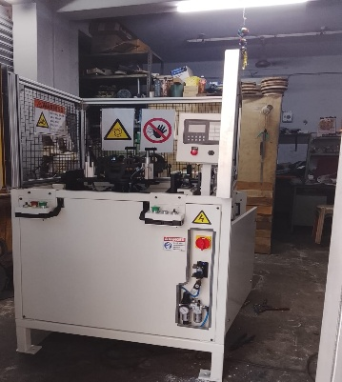 | Machine Front View – Complete | Section 6 – After component table
7.1 | 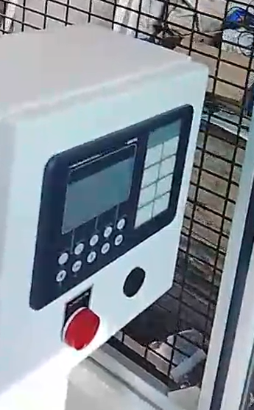 | Control Panel (TEKNIC) | Section 7 – Start of section
7.2 |  | HMI Display Screen | Section 7 – Before heading 7.3
5.1 | 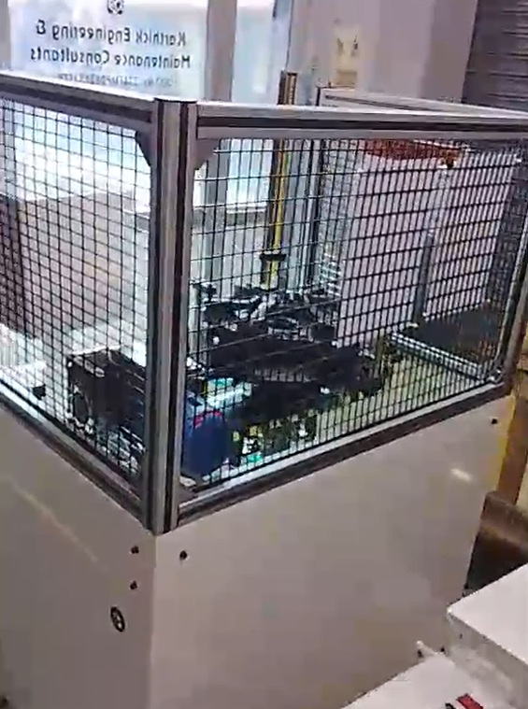 | Fixed Mesh Perimeter Guard | Section 5.1 – After heading
5.2 | 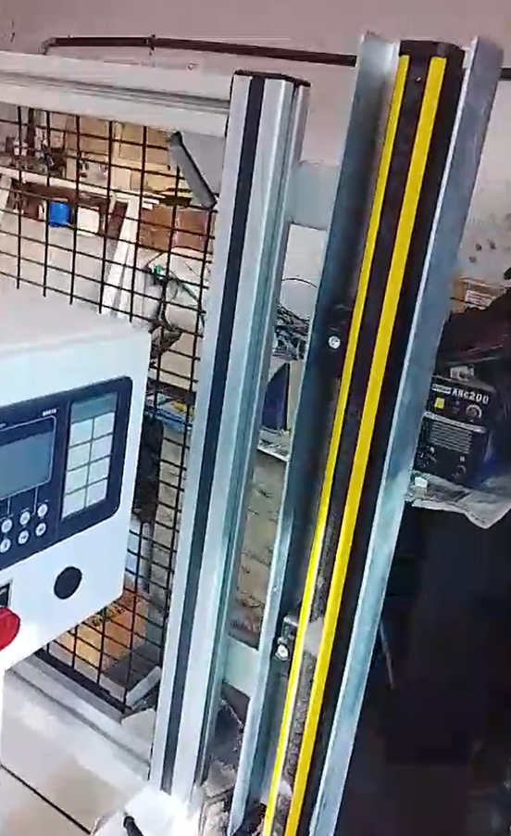 | Light Curtain (Vertical) | Section 5.2 – After heading
5.3 | 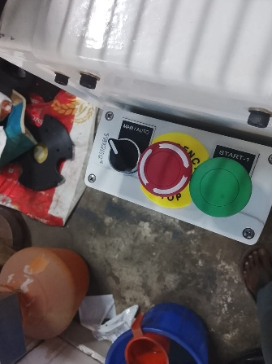 | E-Stop Button (Red Mushroom) | Section 5.4 – After heading
5.4 | 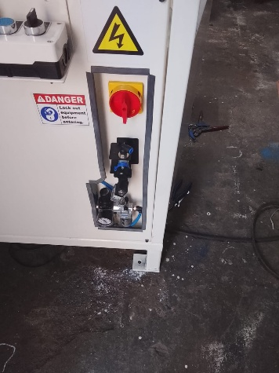 | Blue Pneumatic Isolation Valve | Section 5.5 – After heading
5.5 | 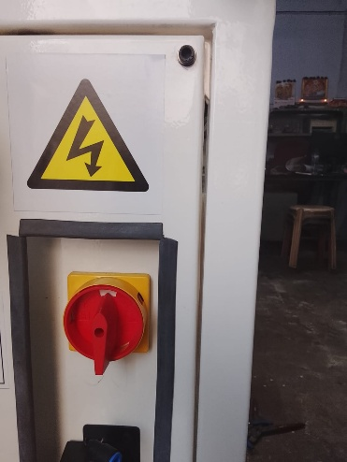 | Main Power Isolator (Red/Yellow) | Section 5.6 – After heading
A1 | 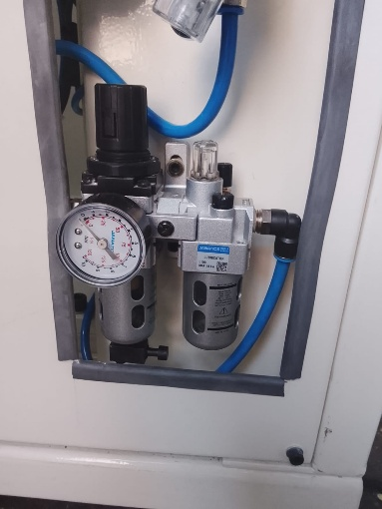 | FRL Unit (JANATICS) with Gauge | Optional – Section 6 components
A2 | 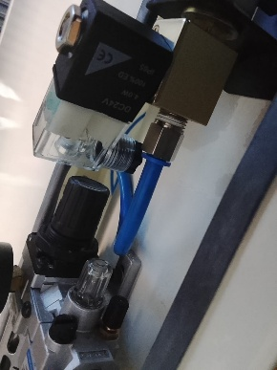 | DC 24V Solenoid Valve | Optional – Section 6 components
A3 | 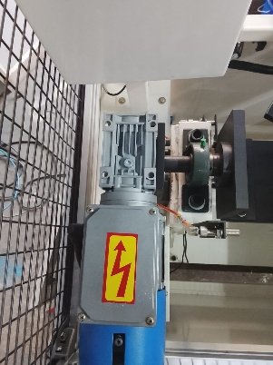 | Electric Motor & Worm Gearbox | Optional – Section 6 components
A4 | 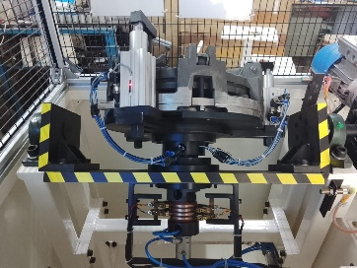 | Tilting Fixture with Workpiece | Optional – Section 6 or 9
A5 | 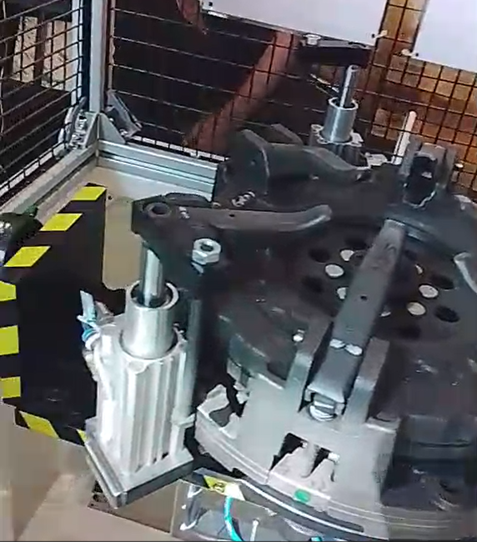 | Pneumatic Clamping Cylinders | Optional – Section 6 components
A6 | 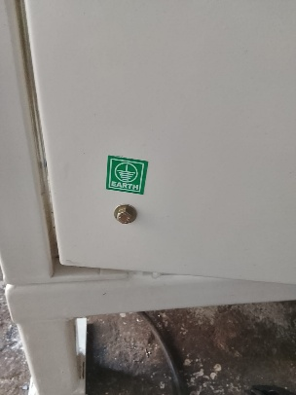 | Earth/Grounding Terminal | Optional – Section 6 components
A7 | 19_34_22_5.jpeg | Electrical Panel Interior (Safety PLC) | Optional – Section 6 components
A8 | 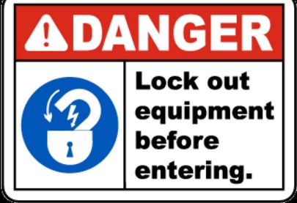 | Safety Warning Signs (ISO 7010) | Optional – Section 4 or 5
A9 |  | ISO 7010 Pictograms Close-up | Optional – Section 4 or 5
A10 |  | Overall Machine Layout | Optional – Cover or Section 1

ℹ NOTE: HOW TO INSERT: Scroll to the blue placeholder box → Right-click inside the box → Insert > Pictures > Select the image file → Delete the blue placeholder box after image is inserted.
Section 1: Machine Identification & Description
1.1 Machine Identification
Machine Name | Dual clutch tilting machine
Machine Type | Assembly Machine – Clutch Plate Positioning & Tilting Station
Manufacturer | Karthick Engineering & Maintenance Consultants (KEMC)
Manufacturing Date | 16 February 2026
Machine Location | No 22/50, Manickavasagam Street, Kumaran Nagar, Padi, Chennai – 600050
End User | Valeo India Pvt. Ltd.
Safety Assessment Report Date | 16 February 2026
Safety Consultant | Mr. Muthu Vignesh R – Independent Safety Assessor
KEMC Contact | Mr. Dhinakaran R – Director, kemckemc1@gmail.com, 9884640770
Asset Number | To be assigned by Valeo
Serial Number | To be assigned by KEMC

1.2 Intended Use
The Dual clutch tilting machine is designed exclusively for the following purpose:
- Safe loading of assembled clutch plates (Models 230, 280, and 310) onto the tilting fixture using a small overhead crane
- Secure clamping of the clutch plate using pneumatic clamping cylinders
- Controlled tilting of the clamped clutch plate to an ergonomically comfortable angle to enable accurate nut installation using a nut runner
- Returning the machine to the home position and safe unloading of the finished component

ℹ NOTE: This machine is intended for INDOOR INDUSTRIAL USE ONLY. The machine must not be used for any purpose other than described above. Any deviation constitutes misuse and voids all safety evaluations.

1.3 Reasonably Foreseeable Misuse
The following uses are PROHIBITED and constitute misuse of this machine:
- Loading components beyond the specified weight capacity
- Bypassing, defeating, or disabling any safety interlock, guard, or light curtain
- Operating the tilting function while the clutch plate is not fully clamped or is incorrectly positioned
- Manual handling of the clutch plate without the crane
- Performing any maintenance, adjustment, or cleaning while the machine is energised (without LOTO)
- Operating the machine in any mode other than Manual or Automatic
- Allowing untrained or unauthorised personnel to operate the machine
- Using the machine in outdoor, wet, or corrosive environments

1.4 Machine Overview – Process Description
The Dual clutch tilting machine processes assembled clutch plates for nut installation in the following sequence:
- The operator lifts the assembled clutch plate using the overhead crane and places it on the tilting fixture
- The machine detects the component presence and the operator initiates the cycle via the START button
- Pneumatic clamping cylinders activate to secure the clutch plate firmly in position
- The electric motor (via worm gearbox) tilts the fixture to the preset working angle
- The operator installs the nuts using the nut runner tool while the part is held at the tilted angle
- The operator signals cycle completion; the machine returns to the home/upright position
- Clamping cylinders release; the operator unloads the finished component using the crane

1.5 Persons Interacting with the Machine
Person Type | Skill Level | Activities
Operator | Instructed | Production, loading/unloading, cycle start, cleaning, changeover
Maintenance Person | Skilled | Troubleshooting, sensor checks, preventive maintenance (every 15 days)
Visitor | Unskilled | Passing by, supervising, observing only – must stay behind safety perimeter
Section 2: Technical Specifications
2.1 Machine Parameters
Electrical Supply | 230 V – Single Phase – 50 Hz
Pneumatic Supply | 5 Bar (regulated)
Hydraulic System | Not applicable
Operating Modes | Manual / Automatic
Operating Hours per Day | 22 hours
Shifts per Day | 3 shifts
Operating Days per Year | 230 days
Workpiece | Assembled Clutch Plate
Clutch Plate Models | Model 230, Model 280, Model 310
Cycle Capacity | One clutch plate per cycle
Tilting Mechanism | Electric motor with worm gearbox
Clamping System | Pneumatic cylinders (DC 24V solenoid valves)
Safety Controller | Safety-Rated PLC Controller
Light Curtain Type | Type 4 Safety Rated Light Curtain
Light Curtain Resolution | 14 mm
Light Curtain Top Beam Height | 1400 mm from ground
Light Curtain Bottom Beam Height | 900 mm from ground
Fixed Guard Height | 700 mm
Fixed Guard Mesh Gap | 20 mm
Control Pendant Brand | TEKNIC
FRL Unit | JANATICS (with pressure gauge, set at 5 bar)

2.2 Workspace & Environmental Conditions
Installation Environment | Indoor industrial environment
Ambient Temperature | Normal industrial ambient (15°C – 45°C)
Humidity | Normal industrial humidity (non-condensing)
Dust / Oil Mist | Free from excessive dust, oil mist, and corrosive vapors
Floor Space Required | Fixed workstation – defined loading/unloading zone
Clearance Required | Sufficient for tilting movement and crane operation overhead
Section 3: Standards & Regulatory Compliance
This machine has been designed and evaluated in accordance with the following standards and directives:

Standard / Directive | Title & Scope
Machinery Directive 2006/42/EC | European Machinery Directive – overarching legal framework
EN ISO 12100:2010 | Safety of Machinery – General Principles for Design – Risk Assessment and Risk Reduction
EN ISO 13849-1:2023 | Safety of Machinery – Safety-Related Parts of Control Systems – General Principles for Design
EN ISO 13850:2015 | Safety of Machinery – Emergency Stop Function – Principles for Design
EN ISO 13854:2019 | Safety of Machinery – Minimum Gaps to Avoid Crushing of Parts of Human Body
EN ISO 13855:2010 | Safety of Machinery – Positioning of Safeguards with Respect to Approach Speeds
EN ISO 13857:2019 | Safety of Machinery – Safety Distances to Prevent Hazard Zones Being Reached
EN ISO 14118:2018 | Safety of Machinery – Prevention of Unexpected Start-Up
EN ISO 14119:2013 | Safety of Machinery – Interlocking Devices Associated with Guards
EN ISO 14120:2015 | Safety of Machinery – Guards – General Requirements for Design and Construction
EN ISO 4414:2010 | Pneumatic Fluid Power – General Rules and Safety Requirements
EN 60204-1:2018 | Safety of Machinery – Electrical Equipment of Machines – Part 1: General Requirements
Section 4: Safety Information & Residual Risks
4.1 Safety Signal Words – Definitions
This manual uses the following signal words to indicate hazard severity:

Signal Word | Meaning
DANGER | Indicates an imminently hazardous situation which, if not avoided, WILL result in death or serious injury.
WARNING | Indicates a potentially hazardous situation which, if not avoided, COULD result in death or serious injury.
CAUTION | Indicates a potentially hazardous situation which, if not avoided, may result in minor or moderate injury.
NOTE | Provides additional information that is important for correct operation but does not involve a hazard.

4.2 Mandatory Personal Protective Equipment (PPE)
All personnel must wear the following PPE at all times when working at or near this machine:
- Safety shoes / Steel-toed footwear (ISO 20345 compliant) – mandatory for all personnel
- Safety gloves – mandatory during loading, unloading, and any manual handling
- Safety glasses – mandatory during all operations
- High-visibility vest – mandatory for visitors and maintenance personnel

⚠ PPE Compliance
Failure to wear the required PPE while operating or maintaining this machine is a serious safety violation. Supervisors are responsible for enforcing PPE compliance at all times.

4.3 General Safety Rules
The following general safety rules MUST be observed at all times:
- Only trained and authorised operators are permitted to operate this machine
- Read and understand this entire manual before operating the machine
- Inspect the machine before each shift – do not operate if any fault or damage is found
- Never defeat, bypass, or disable any safety guard, interlock, or light curtain
- Ensure the light curtain detection zone is completely clear before initiating any cycle
- Keep all non-essential personnel outside the machine perimeter during operation
- In case of any emergency, actuate the red E-STOP button immediately
- Never perform maintenance, cleaning, or adjustment without applying LOTO first
- Report all near-misses, faults, and injuries to the supervisor immediately
- Keep the work area clean and free from oil, chips, or any obstruction

4.4 Risk Summary (Per Machine Safety Assessment – 16/02/2026)
The following risks have been identified, evaluated, and risk reduction measures applied per ISO 12100 and ISO 12100 risk assessment methodology:

Risk ID | Hazard Source | Consequence | Task | Risk IN | Risk OUT | Priority
R001 | Tilting Motor – Moving Element | Shearing | Production Task | 3 | <1 | 3 – Urgent
R002 | Pneumatic Clamping Cylinders | Injection Injury | Production Task | 3 | 3* | 3 – Urgent*
R003 | Electrical Power – Overload | Electrocution | Trouble Shooting | 10 | <1 | 1 – Immediate
R004 | Tilting Motor – Moving Element | Shearing | Cleaning / Maintenance | 3 | <1 | 3 – Urgent
R005 | Short Circuit in Control Panel | Electric Shock | Trouble Shooting | 10 | <1 | 1 – Immediate
R006 | Tilting Motor – Moving Element | Shearing | Visitor | 3 | <1 | 5 – Reasonable
R007 | Pneumatic Clamping Cylinders | Injection Injury | Griping Jaw Setup | 3 | 3* | 3 – Urgent*
R008 | Pneumatic Clamping Cylinders | Injection Injury | Fixture Changeover | 3 | <1 | 3 – Urgent

⚠ Open Action – R002 & R007 (Risk OUT = 3)
R002 (Production) and R007 (Griping Jaw Setup) have a residual Risk OUT of 3 even after all existing measures are applied. The Safety Assessment acknowledges this and requires additional administrative controls: strict adherence to safe work procedures, operator training, and wearing of hand protection (gloves) at all times during these tasks. These risks cannot be fully engineered out with the current machine configuration. Supervisors must ensure compliance.
Section 5: Guarding & Safety Devices
5.1 Fixed Perimeter Guard (SF00)
The machine is enclosed by a fixed perimeter mesh guard on all sides except the operator access side. This guard permanently prevents access to the tilting mechanism and pneumatic components during normal operation.

Guard Type | Fixed – Fabricated mesh guard (not interlocked)
Height | 700 mm from floor level
Length (per panel) | 900 mm approximately
Mesh Gap | 20 mm (compliant with ISO 14120 and ISO 13857)
Standard Reference | ISO 14120, ISO 13857
Safety Function | SF00 – Permanently preventing unauthorised entry/access
Status | Implemented and Maintained

🚫 DANGER – Do Not Remove Fixed Guard
The fixed perimeter guard must NEVER be removed during operation. Removal of any guard panel must only occur as part of an approved LOTO procedure for maintenance. All guard panels must be reinstated before the machine is returned to service.

⚠ Residual Risk – Guard Removal
A residual risk remains if the guard is not replaced after maintenance or repair. Maintenance personnel must verify all guard panels are correctly secured before re-energising the machine.

5.2 Light Curtain – Operator Access Zone (SF13)
A Type 4 safety-rated safety light curtain is installed at the operator access opening. This is the PRIMARY active safeguard protecting the operator during the production cycle.

Device Type | Type 4 Safety-Rated Light Curtain
Manufacturer | Third-Party Supplier
Safety Function | SF13 – Safeguarding work areas shared by humans and machines
Required Performance Level | PLr c (per EN ISO 13849-1)
Top Beam Height (from floor) | 1400 mm
Bottom Beam Height (from floor) | 900 mm
Effective Detection Height | 500 mm (900 mm – 1400 mm zone)
Resolution | 14 mm
Mounting Orientation | Vertical
Standard Reference | ISO 13855
Status | Implemented and Maintained

The light curtain will immediately halt the machine cycle if any object (including the operator's hand or body) enters the detection zone while the machine is in automatic operation. The machine will not restart until the detection zone is completely clear AND a fresh cycle start command is issued.

🚫 DANGER – Do Not Defeat the Light Curtain
The light curtain must NEVER be defeated, masked, or bypassed under any circumstances. Any attempt to override the light curtain is a safety violation that exposes the operator to serious injury risk. The light curtain must be fully functional before any production cycle is started.

⚠ Light Curtain Residual Risks
Two residual risks remain with the light curtain: (1) Inappropriate modification of equipment or fastening solution. (2) Improper location of the detection zone relative to the hazard zone. These must be addressed through periodic inspection and verification of minimum safety distance per ISO 13855.

5.3 Cycle Start Control
The machine uses a single green START-1 pushbutton for cycle initiation. The START button is located on the TEKNIC control pendant at the front of the machine.

Device Type | Single Pushbutton – Cycle Start
Button Colour | Green
Location | TEKNIC control pendant, front of machine
Safety Function | SFXX – Cycle Start Control
Required Performance Level | PLr c
Status | Single button – currently implemented

OPEN ACTION – Safety Assessment Reference: Safety Function SFXX
The Machine Safety Assessment (dated 16/02/2026) recommends upgrading the cycle start control to a TWO-HAND ACTUATING CONTROL per ISO 13851. This device would require simultaneous actuation of two separated buttons, ensuring both operator hands are clear of the hazard zone before the cycle begins.
Current Status: Single START button is in use. Two-hand control is PENDING IMPLEMENTATION by KEMC.
Until the two-hand control upgrade is implemented, the operator MUST ensure: (1) Both hands are withdrawn from the hazard zone. (2) The light curtain detection zone is clear. (3) No other personnel are near the machine. ONLY THEN may the START button be pressed.

5.4 Emergency Stop (SF99)
Two emergency stop devices are provided. These are red mushroom-head pushbuttons that must be actuated in any emergency situation to immediately halt all machine motion.

Device 1 | Front E-Stop – Red mushroom-head pushbutton on control pendant
Device 2 | ON/OFF Switch – Power isolation switch (red/yellow rotary, with lockout provision)
Safety Function | SF99 – Emergency Stop
Required Performance Level | PLr c
Standards | ISO 13850, IEC 60204-1
Status | Both implemented and maintained

The E-Stop must be actuated immediately if:
- Any person enters the hazard zone unexpectedly during machine operation
- Any abnormal machine movement, noise, or vibration is detected
- A component drops, shifts, or is incorrectly clamped
- Any guard is removed or damaged during operation
- The operator feels unsafe for any reason

⚠ E-Stop Reset Procedure
After an E-Stop activation, the machine will NOT automatically restart. The cause of the emergency must be identified and resolved first. Then release the E-Stop (twist to unlock), and follow the normal pre-start check procedure before restarting. See Section 8 for pre-start checks.

5.5 Pneumatic Energy Isolation (SF11)
A blue pneumatic isolation ball valve is provided on the air supply inlet of the FRL (Filter-Regulator-Lubricator) unit. This valve must be operated as part of the LOTO procedure to isolate pneumatic energy before any maintenance.

Device | Pneumatic isolation ball valve – Blue handle
Location | FRL panel / air supply inlet
Safety Function | SF11 – Initiating stop and preventing start (pneumatic energy)
Required Performance Level | PLr c
Standard | ISO 4414
Status | Implemented and Maintained

5.6 Electrical Energy Isolation
A red/yellow rotary main power isolator with lockout provision is located on the machine panel. This must be used as part of the LOTO procedure to isolate electrical energy before any maintenance or troubleshooting.

Device | Red/yellow rotary main power isolator
Lockout Capability | Yes – accepts padlock for LOTO
Safety Function | SF99 – Emergency stop / Energy isolation
Standard | IEC 60204-1
Status | Implemented and Maintained
Section 6: Machine Layout & Component Identification
6.1 Machine Front View – Key Components
The following table identifies all major components visible from the machine front:

Item No. | Component | Description & Location
1 | HMI Display | Located on the upper centre of the control panel. Shows process status, sensor alignment guidance, and fault messages.
2 | Control Panel (TEKNIC) | Main control pendant at front of machine. Houses HMI, mode selector, E-Stop, and START button.
3 | Manual / Auto Mode Selector | Rotary key switch on control panel. Selects operating mode (Manual or Automatic).
4 | START-1 Button (Green) | Green pushbutton on control panel. Initiates the production cycle. See Open Action in Section 5.3.
5 | E-Stop (Red Mushroom Head) | Red mushroom-head pushbutton on front of control panel. Immediately halts all motion.
6 | Main Power Isolator (ON/OFF) | Red/yellow rotary switch with lockout provision. Isolates main electrical supply. Lower panel.
7 | Light Curtain – Transmitter & Receiver | Type 4 safety light curtain. Vertical pair at operator access opening. Active safety zone: 900 mm – 1400 mm from floor.
8 | Fixed Mesh Perimeter Guard | Fabricated steel mesh enclosure. Surrounds machine on all sides except operator access. 700 mm height, 20 mm mesh gap.
9 | FRL Unit (JANATICS) | Filter-Regulator-Lubricator panel. Blue pneumatic isolation valve. Pressure gauge (set: 5 bar). Right side panel.
10 | Pneumatic Isolation Valve | Blue ball valve handle on FRL unit. Isolates compressed air supply for LOTO.
11 | Tilting Fixture / Work Table | Central tilting platform where clutch plate is placed and clamped. Contains pneumatic clamping cylinders.
12 | Pneumatic Clamping Cylinders | Multiple cylinders inside the fixture. Actuated by DC 24V solenoid valves. Hold the clutch plate during tilting.
13 | Electric Motor & Worm Gearbox | Blue motor with worm gearbox. Drives the tilting mechanism. Enclosed inside the mesh guard.
14 | Safety-Rated PLC Controller | Yellow safety PLC inside the electrical panel. Processes all safety function inputs and outputs.
15 | Earth / Grounding Point | Green EARTH label on panel body. Grounding terminal for electrical safety.
16 | ISO 7010 Warning Signs | Yellow/black safety pictograms on machine frame: auto-restart, crush/cut hazard, electrical hazard, LOTO required.

📷 IMAGE PLACEHOLDER
Figure 6.1: Machine Front View – Complete
Insert Image: WhatsApp_Image_2026-02-17_at_19_34_15_12.jpeg
(Machine front view showing control panel, guards, light curtain, FRL unit)

Section 7: Control Panel & HMI Description
📷 IMAGE PLACEHOLDER
Figure 7.1: Control Panel (TEKNIC)
Insert Image: WhatsApp_Image_2026-02-17_at_19_34_16_13.jpeg
(Control panel showing HMI, mode selector, START button, E-Stop)

7.1 Control Panel Overview
The TEKNIC control pendant is the primary operator interface. All controls required for normal production operation are located on this panel.

ℹ NOTE: Image Placeholder: Insert annotated control panel photograph here, with each control element labelled.

7.2 Control Elements – Description
Control Element | Type / Colour | Function
HMI Display Screen | Digital display | Shows process status, current model selected, sensor alignment guidance during changeover, and fault/alarm messages.
Manual / Auto Selector | Key-operated rotary switch | Selects operating mode. Manual mode for setup, changeover, and maintenance. Automatic mode for production operation.
START-1 Button | Green pushbutton | Initiates the production cycle in Automatic mode. See Open Action – Section 5.3. Do not press until the hazard zone is confirmed clear.
E-Stop Button (Front) | Red mushroom-head pushbutton | Immediately halts ALL machine motion. Actuate in any emergency. Must be released (twist to unlock) before restart.
ON/OFF Power Isolator | Red/yellow rotary switch | Main electrical power isolation. Must be turned OFF and locked for LOTO. Located lower panel / side panel.

📷 IMAGE PLACEHOLDER
Figure 7.2: HMI Display Screen
Insert Image: WhatsApp_Image_2026-02-17_at_19_34_24.jpeg
(HMI display panel showing status information)

7.3 HMI Display Information
The HMI display provides the following information to the operator:
- Current operating mode (Manual / Automatic)
- Current clutch plate model loaded (230 / 280 / 310) – for changeover reference
- Sensor alignment status during griping jaw setup
- Fault and alarm messages with fault codes
- Cycle status (Idle / Clamping / Tilting / Return / Complete)

ℹ NOTE: If the HMI shows a fault code or alarm, stop the cycle, note the fault code, and refer to Section 11 (Troubleshooting) before proceeding.
Section 8: Pre-Start Checks
Before starting the machine at the beginning of every shift, the operator must carry out the following pre-start inspection. Do NOT start the machine if any item fails the check.

8.1 Pre-Start Inspection Checklist
No. | Inspection Item | Acceptable Condition | Status
1 | All fixed mesh guard panels are in position, undamaged, and fully secured | All present & secured | ☐ Pass  ☐ Fail
2 | Light curtain transmitter and receiver are clean, undamaged, and aligned (status indicator green) | Green status indicator | ☐ Pass  ☐ Fail
3 | E-Stop button (front) is released (not depressed) and functioning | Button out / active | ☐ Pass  ☐ Fail
4 | Main power isolator is in the ON position | Rotary switch ON | ☐ Pass  ☐ Fail
5 | Pneumatic supply is connected and pressure gauge reads 5 bar | Gauge at 5 bar ± 0.2 bar | ☐ Pass  ☐ Fail
6 | Blue pneumatic isolation valve is in the OPEN position | Handle aligned with pipe | ☐ Pass  ☐ Fail
7 | No tools, workpieces, or foreign objects are left inside the machine enclosure | Enclosure clear | ☐ Pass  ☐ Fail
8 | Tilting fixture is in the home (upright) position | Fixture upright | ☐ Pass  ☐ Fail
9 | Clamping cylinders are in the open/retracted position | Cylinders retracted | ☐ Pass  ☐ Fail
10 | ISO 7010 warning signs are visible, undamaged, and legible | All signs legible | ☐ Pass  ☐ Fail
11 | Work area floor is clean, dry, and free from oil or obstruction | Clean & dry | ☐ Pass  ☐ Fail
12 | HMI display powers up correctly with no fault codes displayed | No fault codes | ☐ Pass  ☐ Fail
13 | Operator is wearing required PPE (safety shoes, gloves, glasses) | Full PPE | ☐ Pass  ☐ Fail
14 | Overhead crane is operational and hook is accessible | Crane serviceable | ☐ Pass  ☐ Fail

🚫 DANGER – Do Not Start If Any Check Fails
If any pre-start check item FAILS, do NOT operate the machine. Inform your supervisor and the maintenance team immediately. Document the failure in the machine log. The machine must not be restarted until the issue is resolved and the failed check passes.

8.2 Machine Energisation Sequence
After all pre-start checks are confirmed PASS:
- Turn the main power isolator to ON position
- Open the blue pneumatic isolation valve (handle parallel to pipe)
- Confirm HMI display powers up and shows no fault codes
- Select the required operating mode (Manual or Automatic) using the mode selector
- The machine is now ready for operation
Section 9: Normal Operating Procedure
🚫 DANGER – Read Before Operating
The tilting motion and pneumatic clamping create shearing and injection hazards. NEVER insert hands or any body part into the machine enclosure during operation. NEVER defeat or bypass the light curtain. Ensure the detection zone is clear before pressing START.

9.1 Step-by-Step Production Cycle (Automatic Mode)

STEP 1 – Mode Selection
Turn the mode selector to AUTOMATIC mode. The HMI will display 'AUTO MODE – READY'.

STEP 2 – Load Clutch Plate onto Fixture
Using the overhead crane and appropriate lifting sling:
- Attach the lifting sling to the clutch plate as per the approved lifting procedure
- Slowly lift and manoeuvre the clutch plate over the tilting fixture
- Lower the clutch plate onto the fixture, aligning it with the locating features
- Confirm the clutch plate is fully seated and correctly positioned on the fixture
- Remove the lifting sling from the clutch plate
- Ensure the crane hook is raised clear of the machine enclosure

⚠ Crane Safety
Always use the overhead crane for loading and unloading clutch plates. Never attempt to manually lift or carry the clutch plate into the machine. Ensure the crane operator and machine operator communicate clearly before lifting.

STEP 3 – Confirm Hazard Zone is Clear
Before pressing the START button, confirm ALL of the following:
- Both your hands are completely withdrawn from the machine enclosure
- No tools, slings, or other objects are inside the enclosure
- No other personnel are within the light curtain detection zone (900 mm – 1400 mm from floor)
- The light curtain status indicator is GREEN

STEP 4 – Initiate Cycle (Press START)
With the hazard zone confirmed clear, press the green START-1 button on the control pendant.

ℹ NOTE: OPEN ACTION – Safety Assessment: The Safety Assessment recommends a two-hand cycle start (ISO 13851) to formally ensure both operator hands are clear before the cycle begins. This upgrade is pending. Until implemented, the operator must manually ensure both hands are clear before pressing START (single button).

STEP 5 – Automatic Clamping
Upon START activation, the safety controller will:
- Verify the light curtain is unobstructed
- Activate the pneumatic solenoid valves to extend the clamping cylinders
- Clamp the clutch plate firmly in position
The HMI will display 'CLAMPING IN PROGRESS' followed by 'CLAMPED – READY TO TILT'.

⚠ Do Not Enter During Clamping
Pneumatic cylinders move rapidly and generate high clamping force. If the light curtain is triggered during clamping, the machine will halt and clamping will stop. The operator must withdraw, resolve the issue, and restart the cycle.

STEP 6 – Automatic Tilting
After successful clamping, the machine automatically tilts the fixture:
- The electric motor activates via the worm gearbox
- The fixture tilts the clutch plate to the preset working angle
- The HMI displays 'TILTING IN PROGRESS' followed by 'AT WORKING ANGLE – READY'

⚠ Tilting Motion Hazard
The tilting motor creates a shearing hazard between the rotating fixture and the fixed machine frame. NEVER reach into the machine enclosure during tilting. If unexpected noise or vibration is detected, press E-STOP immediately.

STEP 7 – Nut Installation
With the clutch plate clamped and tilted to the working angle:
- Pick up the nut runner tool
- Approach the tilted clutch plate from the front operator access
- Install the required nuts at all specified positions as per the product work instruction
- Apply the correct torque as specified in the product drawing or work instruction
- Visually confirm all nuts are installed and properly seated
The HMI will display the current model and the required torque value for reference.

⚠ Nut Runner Safety
Maintain firm control of the nut runner at all times. Ensure the nut runner cable does not enter the light curtain detection zone or the machine enclosure. Use anti-vibration gloves if the nut runner produces excessive vibration.

STEP 8 – Cycle Completion Signal
After all nuts are installed, signal cycle completion by pressing the START-1 button again (or follow the specific cycle completion input defined by KEMC during commissioning). The HMI will display 'RETURNING TO HOME'.

STEP 9 – Automatic Return & Unclamp
The machine automatically:
- Tilts the fixture back to the home (upright) position
- Confirms the home position via limit switch
- Retracts the pneumatic clamping cylinders to release the clutch plate
- The HMI displays 'CYCLE COMPLETE – READY TO UNLOAD'

STEP 10 – Unload Finished Component
Using the overhead crane:
- Attach the lifting sling to the finished clutch plate
- Gently lift the clutch plate clear of the fixture
- Manoeuvre and lower the finished part to the outgoing pallet or station
- The machine is now ready for the next cycle – return to STEP 2

ℹ NOTE: The operator should perform a quick visual check of the finished part before placing it on the outgoing pallet. Any part with visibly missing or incorrectly installed nuts must be quarantined and reported to the supervisor.
Section 10: Setup & Changeover Procedures
🚫 DANGER – LOTO Required for Fixture Base Plate Changeover
Fixture base plate changeover (R008) requires full LOTO before any physical adjustment. Refer to Section 13 for the complete LOTO procedure.

10.1 Griping Jaw Setup – Model 280 Adjustment (R007)
When changing production to Model 280, the griping jaw requires adjustment:

⚠ Pneumatic Injection Hazard – R007
Pneumatic clamping cylinders remain energised during griping jaw setup unless LOTO is applied. The Safety Assessment identifies this as a Risk OUT of 3 (Urgent). Wear gloves at all times during this task. Do not place hands near clamping cylinder actuation paths.

Griping Jaw Setup Procedure:
- Switch the mode selector to MANUAL mode
- The HMI will display sensor alignment guidance for the 280 model
- Using the 3 mm spanner, adjust the bolts and nuts at each stage of the jaw as indicated by the HMI sensor alignment display
- After each adjustment, check the HMI for 'Sensor Aligned' confirmation
- Repeat for each jaw stage until all sensors confirm alignment
- Perform a trial clamp in MANUAL mode to verify correct clamping
- Switch back to AUTOMATIC mode for production

ℹ NOTE: During griping jaw setup, follow all LOTO and administrative controls as required. If in doubt about whether the machine is fully de-energised, apply LOTO before touching any clamping component.

10.2 Fixture Base Plate Changeover (R008)
Three base plates are available for Models 230, 280, and 310. Changeover frequency varies from 1 hour to 1 week depending on production demand.

Fixture Base Plate Changeover Procedure:
- Inform the supervisor that a changeover is being performed
- Complete all current production cycles and ensure no clutch plate is on the fixture
- Apply full LOTO as per Section 13 (isolate electrical and pneumatic energy)
- Remove the locking fasteners from the current base plate
- Carefully lift and remove the current base plate using appropriate lifting equipment if required
- Select and position the new base plate for the required model (230, 280, or 310)
- Secure the new base plate with all fasteners to the specified torque
- Remove LOTO devices and restore energy sources
- Perform a trial cycle in MANUAL mode to verify correct operation with the new base plate
- Update the HMI with the new model selection
- Inform the supervisor that changeover is complete
Section 11: Troubleshooting Guide
⚠ Important
Operators may only perform the operator-level troubleshooting steps listed below. Any troubleshooting that requires opening electrical panels or disassembly of machine components must be performed by authorised maintenance personnel ONLY, with full LOTO applied.

11.1 Troubleshooting Table
Symptom / Fault | Probable Cause | Corrective Action
Machine does not start when START is pressed | Light curtain is obstructed or misaligned | Check light curtain detection zone. Remove any obstruction. Verify green status indicator. Press START again.
Machine does not start when START is pressed | E-Stop is depressed | Check both E-Stop buttons. Release (twist to unlock) if depressed. Resume pre-start check before restarting.
Machine does not start when START is pressed | Mode selector in MANUAL | Switch mode selector to AUTOMATIC mode.
Machine does not start when START is pressed | Pneumatic pressure low | Check FRL pressure gauge – must read 5 bar. Check air supply connection. Report to maintenance if pressure cannot be restored.
Clamping cylinders do not actuate | Solenoid valve fault or low air pressure | Check HMI for fault code. Verify pneumatic pressure at gauge. Stop operation and call maintenance.
Machine tilts but clutch plate is not secure | Clamping not confirmed before tilting | Activate E-Stop immediately. Do not attempt to manually hold the part. Call maintenance to check clamping sensor and cylinder.
Tilting motion is jerky or makes unusual noise | Motor or gearbox fault; foreign object in mechanism | Activate E-Stop. Do not operate. Report to maintenance immediately.
Light curtain status is red / not green | Object in detection zone; dirty optics; misalignment | Check and clear detection zone. Clean light curtain lenses with dry lint-free cloth. Check alignment. If problem persists, call maintenance.
HMI shows fault code | Various – refer to fault code | Note the fault code. Stop the cycle. Refer to HMI fault code list (posted at machine). Call maintenance for fault codes not in the list.
Machine stopped mid-cycle due to E-Stop | E-Stop was actuated | Identify and resolve the cause. Release E-Stop. Perform full pre-start check (Section 8). Restart cycle.
Clamping cylinders remain pressurised after cycle | Solenoid valve stuck; control fault | Do NOT reach into the clamping area. Apply LOTO. Call maintenance.
Unusual vibration during tilting | Clutch plate not correctly seated; motor/gearbox issue | Activate E-Stop. Do not restart. Report to maintenance. Check that clutch plate was correctly positioned before next cycle.

🚫 DANGER – Electrocution Risk – R003 & R005
Do NOT open the electrical panel or attempt any electrical troubleshooting unless you are a qualified electrician with appropriate authorisation. Electrical faults carry a Risk IN of 10 (IMMEDIATELY priority). Always apply LOTO before opening any electrical enclosure.
Section 12: Cleaning Procedures
⚠ Tilting Motor Hazard During Cleaning – R004
The tilting motor creates a shearing hazard during cleaning near the tilting mechanism. Apply LOTO before cleaning inside the machine enclosure. For external cleaning only (floor around machine, outer panels), LOTO is not required but the machine must be in STOP state.

12.1 Routine Cleaning – Operator (Each Shift)
The following cleaning tasks must be performed by the operator at the end of each shift or as required during the shift:

External Cleaning (Machine in STOP state):
- Press E-Stop or set mode to MANUAL and ensure machine is stationary
- Sweep or vacuum chips and debris from the work area floor around the machine
- Wipe down external surfaces of the machine enclosure with a dry or slightly damp cloth
- Check and clean the light curtain optics with a dry lint-free cloth – avoid abrasive materials
- Remove any oil spills on the floor immediately using absorbent material
- Dispose of cleaning waste per factory waste management procedures

Internal Cleaning (LOTO Required):
- Apply full LOTO as per Section 13 (isolate electrical AND pneumatic energy)
- Open or remove the required guard panel only after LOTO is confirmed
- Remove chips, oil, and debris from the fixture, clamping cylinders, and tilting mechanism using brush or vacuum
- Wipe down fixture surfaces with a clean cloth
- Check clamping cylinder rods for cleanliness and damage – clean with dry cloth
- Do NOT use high-pressure air to blow chips as this can project debris
- Replace all guard panels and confirm secure
- Remove LOTO and restore energy before resuming production

12.2 Lubrication (Maintenance – Every 15 Days)
Lubrication is performed by the authorised maintenance person as part of the preventive maintenance programme (PM every 15 days):
- Lubricate worm gearbox per manufacturer specification
- Apply grease to tilting mechanism pivot points as required
- Check and lubricate FRL lubricator level – top up if required with the recommended pneumatic lubricant
- Check cylinder rod surfaces – apply a light film of compatible lubricant if required

ℹ NOTE: All lubricants must be compatible with pneumatic seals and food-grade requirements if applicable. Use only approved lubricants as specified by KEMC. Record all lubrication in the maintenance log (Annex C).
Section 13: Maintenance & LOTO Procedures
🚫 DANGER – LOTO is Mandatory
Lockout / Tagout (LOTO) must be applied before ANY maintenance, repair, cleaning inside the enclosure, or adjustment on this machine. Failure to apply LOTO when required may result in DEATH or serious injury.

13.1 Energy Sources on This Machine
Energy Source 1 – Electrical | 230 V Single Phase AC via main power isolator (red/yellow rotary switch)
Energy Source 2 – Pneumatic | 5 bar compressed air via blue pneumatic isolation ball valve on FRL unit
Stored Energy – Pneumatic | Pressure trapped in cylinders and pipework after isolation – must be vented
Stored Energy – Gravity (Tilting) | If fixture is at tilted position, gravity load remains. Machine must be in home (upright) position before LOTO.

13.2 LOTO Procedure – Step by Step

Step | Action Required | Verification
1 | NOTIFY: Inform all personnel in the area that the machine is being isolated for maintenance. Ensure no one is inside the machine enclosure. | Verbal notification complete
2 | STOP: Press E-Stop or set mode selector to MANUAL. Ensure all machine motion has completely stopped. | Machine fully stopped
3 | RETURN TO HOME: If the fixture is tilted, use MANUAL mode to return it to the upright home position before proceeding. | Fixture at home position
4 | ISOLATE ELECTRICAL: Turn the main power isolator (red/yellow rotary) to the OFF position. | Isolator in OFF position
5 | LOCKOUT ELECTRICAL: Apply your personal padlock to the main power isolator lockout hasp. Retain the key. | Padlock applied – key retained
6 | TAGOUT ELECTRICAL: Attach a 'DO NOT OPERATE – MAINTENANCE IN PROGRESS' tag to the isolator. | Tag attached and legible
7 | ISOLATE PNEUMATIC: Turn the blue pneumatic isolation ball valve to the CLOSED position (handle perpendicular to pipe). | Blue valve closed
8 | VENT STORED PRESSURE: Manually vent any trapped pressure from cylinders per the cylinder venting procedure. Confirm pressure gauge reads zero. | Gauge reads zero / 0 bar
9 | VERIFY ZERO ENERGY: Attempt to start the machine by pressing START. Confirm machine does NOT start. | Machine does not start on START press
10 | COMMENCE MAINTENANCE: Only after all steps above are confirmed – proceed with maintenance. | Authorised maintenance begins

13.3 Restoring Energy After Maintenance (LOTO Release)
- Confirm maintenance is fully complete and all tools/parts are accounted for
- Ensure all guard panels are reinstated and fully secured
- Notify all personnel that LOTO is being released and the machine is about to be re-energised
- Confirm no one is inside the machine enclosure
- Open the blue pneumatic isolation valve (handle parallel to pipe)
- Remove your personal padlock and LOTO tag from the main power isolator
- Turn the main power isolator to ON
- Perform the full pre-start check (Section 8) before resuming production

🚫 DANGER – Multiple LOTO Devices
If more than one person is working on the machine, EACH person must apply their own personal padlock and tag. Only the person who applied their padlock may remove it. The machine must not be re-energised until ALL padlocks are removed.

13.4 Preventive Maintenance Schedule
Maintenance Task | Frequency | Responsible | Remarks
Pre-start inspection (Section 8) | Every shift | Operator | Record in shift log
Light curtain optics cleaning | Every shift | Operator | Use dry lint-free cloth only
Floor and external cleaning | Every shift | Operator | Remove chips and oil spills
Internal fixture cleaning | Weekly or as needed | Operator / Maintenance | LOTO required
Lubrication – gearbox, pivots, FRL | Every 15 days | Maintenance | Use approved lubricants. Record in Annex C
Sensor and limit switch check | Every 15 days | Maintenance | Check alignment and response. LOTO required
Cylinder condition check | Every 15 days | Maintenance | Check for leaks, rod damage, seal wear
Light curtain alignment & safety distance check | Monthly | Maintenance / Safety | Verify per ISO 13855
E-Stop function test | Monthly | Maintenance | Actuate and verify machine halts
SRPCS (Safety PLC) diagnostic check | Monthly | Maintenance | Check status LED and fault log
Full electrical inspection | Annually | Qualified Electrician | IEC 60204-1 compliance
Full machine safety re-evaluation | Every 3 years or after modification | Safety Officer / Independent Assessor | Update RA if machine is modified
Section 14: Decommissioning
14.1 Temporary Shutdown
For temporary shutdown at the end of a shift or for maintenance:
- Complete the current cycle and ensure no clutch plate is on the fixture
- Set the mode selector to MANUAL
- Confirm the tilting fixture is in the home (upright) position
- Press E-Stop to halt the machine
- Turn the main power isolator to OFF
- Close the blue pneumatic isolation valve
- Record the machine shutdown in the shift log

14.2 Planned Decommissioning
When the machine is to be decommissioned permanently or relocated:
- Inform KEMC and Valeo management and obtain written authorisation
- Complete all current production and clear the machine
- Apply full LOTO as per Section 13
- Disconnect all energy sources – electrical and pneumatic
- Drain and vent all pneumatic circuits
- Remove and retain all safety devices (light curtain, SRPCS) for reuse or proper disposal
- Dispose of all mechanical, electrical, and pneumatic components per applicable environmental and waste management regulations
- Retain all documentation (this manual, Safety Assessment report, maintenance logs) for a minimum of 10 years

ℹ NOTE: Any modification or recommissioning of this machine after decommissioning requires a new risk assessment to be performed by an independent qualified body before the machine is returned to service.
Annex A: Risk Assessment Traceability Matrix
This matrix traces each identified risk from the Machine Safety Assessment (16/02/2026) to the corresponding sections in this manual where the risk is described and the risk reduction measures are documented.

Risk ID | Hazard & Task | Consequence | Risk IN | Risk OUT | Manual Section (Risk Reduction)
R001 | Tilting Motor – Production Task | Shearing | 3 | <1 | Sec 5.2 (Light Curtain), Sec 5.3 (Cycle Start), Sec 5.4 (E-Stop), Sec 5.1 (Fixed Guard), Sec 9
R002 | Pneumatic Cylinders – Production Task | Injection | 3 | 3* | Sec 5.2 (Light Curtain), Sec 5.3 (Cycle Start), Sec 5.5 (Air Isolation), Sec 9 – OPEN RISK
R003 | Electrical Power – Troubleshooting | Electrocution | 10 | <1 | Sec 5.6 (Electrical Isolation), Sec 13 (LOTO), Sec 11
R004 | Tilting Motor – Cleaning / Maintenance | Shearing | 3 | <1 | Sec 5.2 (Light Curtain), Sec 5.4 (E-Stop), Sec 5.5 (Air Isolation), Sec 12, Sec 13 (LOTO)
R005 | Short Circuit – Control Panel – Troubleshooting | Electric Shock | 10 | <1 | Sec 5.6 (Power Isolation), Sec 13 (LOTO), Sec 11
R006 | Tilting Motor – Visitor | Shearing | 3 | <1 | Sec 5.1 (Fixed Guard), Sec 5.2 (Light Curtain), Sec 4.3 (Safety Signs)
R007 | Pneumatic Cylinders – Griping Jaw Setup | Injection | 3 | 3* | Sec 5.2, 5.3, 5.4, 5.5, Sec 10.1 – OPEN RISK
R008 | Pneumatic Cylinders – Fixture Changeover | Injection | 3 | <1 | Sec 5.5, 5.6, Sec 10.2, Sec 13 (LOTO)

⚠ Open Actions – R002 & R007
* Risk OUT = 3 for R002 and R007 indicates these risks remain at 'URGENT' level even with all measures applied. The two-hand cycle start (SFXX) is recommended by the Safety Assessment but pending implementation. Administrative controls (training, SWP, PPE) are essential until the engineering upgrade is complete.
Annex B: LOTO Procedure – Pictorial Reference
The following pictorial summary must be posted at the machine workstation. It provides a quick visual reference for the LOTO sequence.

ℹ NOTE: Image Placeholder: Insert a custom LOTO pictorial card here showing: (1) Main power isolator – OFF + padlock. (2) Blue pneumatic valve – CLOSED. (3) Vent residual air – pressure gauge at zero. (4) Verify zero energy – press START, machine must not respond. (5) LOTO tag with operator name, date, and signature.

B.1 LOTO Equipment Required
Padlock (1 per person) | Personal padlock with unique key – must be retained by the person performing maintenance
LOTO Tag | 'DO NOT OPERATE – MAINTENANCE IN PROGRESS' tag – name, date, and reason to be filled
LOTO Hasp | Multi-lock hasp on main power isolator – allows multiple padlocks for multiple workers
Energy Isolation Points | 1. Main power isolator (electrical) – 2. Blue pneumatic ball valve (pneumatic)

B.2 LOTO Tag Information
Each LOTO tag must show:
- Name of person performing maintenance
- Date and time LOTO was applied
- Reason for isolation
- Expected completion time
- Supervisor notified – name
Annex C: Inspection & Maintenance Log
This log must be maintained at the machine. All inspections, maintenance activities, faults, and repairs must be recorded here.

Date | Time | Activity / Observation | Action Taken | Technician Name | Sign

